UMGC Pasadena Chatbot Runbook

Version 1.0

April 19, 2020

Resources 3

Dialogflow 4

IBM Watson 5

Codebase 6

Dialogflow build 6

IBM Watson build 6

# 

# Resources

|  |  |  |
| --- | --- | --- |
| Modules | Address | Authentication |
| Dialogflow | <https://dialogflow.cloud.google.com/> | Username: umgchatbot@gmail.com  Password: <will be provided to the City of Pasadena> |
| IBM Watson | <https://cloud.ibm.com/> | Username: umgchatbot@gmail.com  Password: <will be provided to the City of Pasadena> |
| Codebase | [Github](https://github.com/umgc/umgc.city.frontend.git) (<https://github.com/umgc/umgc.city.frontend.git>) | The city of Pasadena can create a GitHub account and request Admin privileges on the repository. |

## 

## Dialogflow

To access the Dialogflow Agent <https://dialogflow.cloud.google.com/> use the [umgchatbot@gmail.com](mailto:umgchatbot@gmail.com) provided credentials. The Dialogflow Agent UMGC_CHATBOT is the main Agent for the City of Pasadena chatbot.

For more information on how to create Intents, Entities and manage all Dialogflow feature please consult Dialogflow Official Documentation (<https://cloud.google.com/dialogflow/docs/>)

Currently, three services are attached to UMGC_CHATBOT

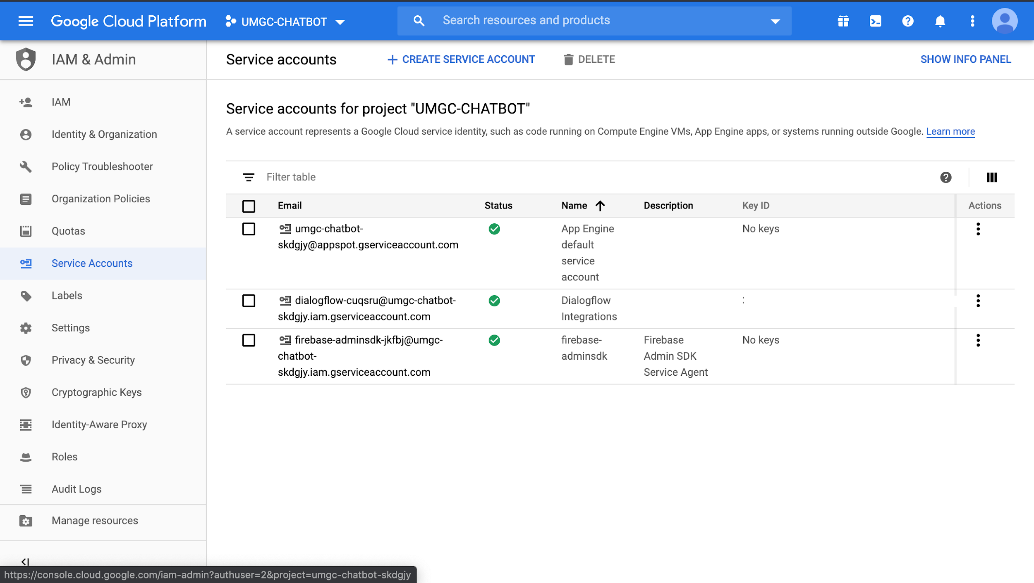

## 

## IBM Watson

To access the IBM Waston Agent <https://cloud.ibm.com/developer/watson/dashboard> use the [umgchatbot@gmail.com](mailto:umgchatbot@gmail.com) provided credentials. The IBM Watson Agent UMGCbot assistant is the main Agent for the City of Pasadena chatbot.

For more information on how to create Intents, Entities and manage all Dialogflow feature please consult IBM Watson Official Documentation (<https://cloud.ibm.com/developer/watson/documentation>)

Currently, one service is attached to UMGCbot assistant

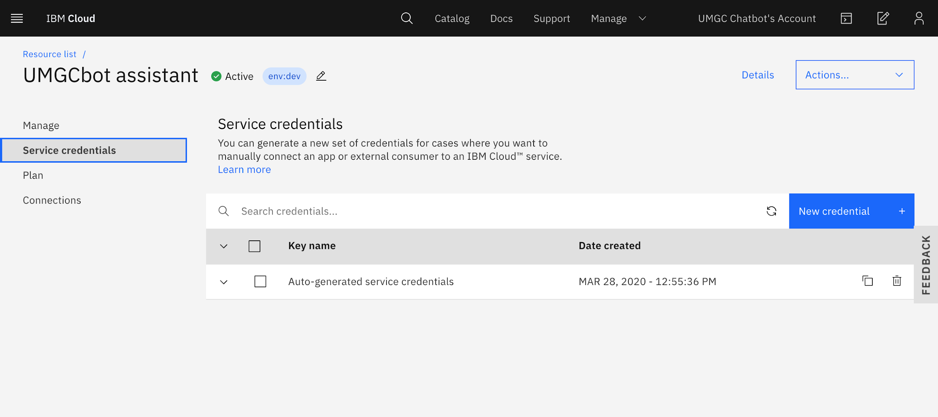

## Codebase

The codebase for the City of Pasadena Chatbot resides at GitHub with this address

<https://github.com/umgc/umgc.city.frontend.git>

This project was generated with Angular CLI version 8.2.2, to build and run the project locally:

* Clone the repository

|  |
| --- |
| git **clone** **https**://github.com/umgc/umgc.city.frontend.git |

* Build the project  
  Run ng build to build the project. The build artifacts will be stored in the **dist/** directory. Use the --prod flag for a production build.
* Local Development Server  
  Run ng serve for a dev server. Navigate to http://localhost:4200/. The app will automatically reload if you change any of the source files.

### Dialogflow build

To build a Dialogflow implementation run the following command

|  |
| --- |
| ng build --configuration=watson --base-href=/chatbot/ |

### IBM Watson build

To build a Dialogflow implementation run the following command

|  |
| --- |
| ng build --configuration=dialogflow --base-href=/chatbot/ |